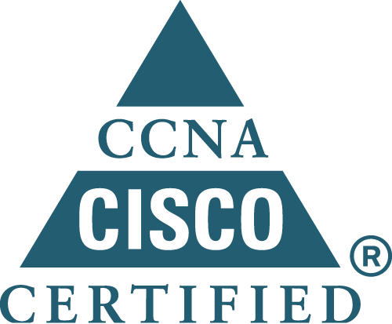

DILSHAD TP
Network & Security Engineer With 4.2 Years Exp.
HCL INFOSYSTEMS LTD
BANGALORE-01
Email: dilutpedv@gmail.com
Cell : 09035665348,09895362108

Career Objective

To work for a growing and challenging organization having an innovative environment that will best utilize my creativity and analytical skills and allow me to be part of a creative team. Dedicated self-motivated achiever who is committed to success and adapt at juggling multiple tasks in a high-pressured environment.

Experience Summary

Company's Name:HCL INFOSYSTEMS LTD .

Job Profile: - Worked as Network CUM SECURITY Engineer.
Duration:- 16^{th JULY}-09 to 15-jan-10 (HCL CDC) – Part of hcl infosystems Ltd Duration:- 15-Feb-10 -presently working.
Designation:- Customer Engineer.

Job Responsibilities

• To Administer and maintain the network, and to apply expertise for network expansion.
•Implemented the network with security device Firewall ASA 5500 Series.
• Configuring, Administrating, Installing L2 & L3 switches in a LAN environment.
• Assisted in maintaining and improving system/network environment and proactively monitor the Network to avoid potential issues.
• Participate in upkeep of the network and all perennials connected to it, which entailed printers, modems, NIC cards, etc.
• Physically secure the network equipment.

Technical Skill
- Configuring and trouble shooting of Cisco Firewall ASA 5500 series.
- Configuring and trouble shooting of Fortinet Firewall.
- Configuring and trouble shooting of checkpoint 12407 series for SSL VPN using mobile access blade.
- Configuration of Cisco Routers (1841,2811,7609,7606)
- Configuring and trouble shooting of Cisco Switches (2960,3750,4503,6513)
- Installation of IOS in Cisco routers and Switches.
- Password recovery of cisco routers and switches.
- IP Routing-Static,Default and Dynamic,.
- Configuration of VLAN and INTERVLAN Routing.
- Configured Protocols like RIP, EIGRP, STP and BGP
- NAT,PAT,ACL and for router redundancy-HSRP.
- Talented in trouble shooting hardware problems.
- For network security-Navigating ASDM configuration windows and configuration of security appliances.
- VPN configuration in ASA,Configuring Security appliances Remote access VPNs,Working with CISCO VPN client and Configuring ASA for SSL VPN.

Academic / Professional Profile

Examination | Discipline/  Specialization | School/College | Board/  University | Year of Passing | %
B.TECH | Electronics & Communication Engineering. | MEA Engineering College, Perinthalmanna. | Calicut  University | 2009 | 61.18
+2 | Science | MES Mampad. | State Board | 2004 | 69.66
SSLC | General | SHMGVHSS Edavanna | State Board | 2002 | 73.83

Project Details

- CEN(Carrier Ethernet Network) project for Vodafone
CEN is the foundation of a secure, flexible and intelligent multi-service transport network for the delivery of Mobile & business services. CEN which resides in single state are also connected to each other via DWDM network. Each CEN will have a Core ring consisting of C-18 routers, and each C-18 router aggregates multiple rings consisting of C-16 routers. Each C-16 router has multiple rings consisting of C-16b or C14 devices.
- Installation and basic configuration of aggregation Routers (7606&7609).
- Installation and basic configuration catalyst switches (4948,3400)
- Conduct AT (Acceptance Testing) according to the scheme.
GPON(Gigabit Passive Optical Network) project for BSNL
The GPON network is an end-to-end, well-engineered, carrier-class optical network designed to deliver triple-play services (voice, video, and data) from a Central Office to individual businesses or dwellings.

- Installation of OLT equipment.
- Up gradation of OS and Integration.
- IPTV,VOIP and HSI configuration of client side.

Personal Skills

- Ability to accept any challenge with an optimistic outlook.

- Ability to deal with the people loyally, ability to lead, team facilitator, willingness to learn, good listener and hard working.
- Designing and implementation of customers network infrastructure.

Professional Certification
- Cisco Certified Network Adminidtration (CCNA).
- Microsoft Certified System Administration (MCSA).

Linguistic Abilities

- English
- Malayalam
- Tamil
- Kannada
- Hindi

Personal Profile

Date of Birth :19/04/1987
Age :26
Sex :Male
Marital Status :Single
Nationality :Indian
Religion :Islam
Father’s Name :Veerankutty T
Permanent Address :Thandupara(H),Edavanna (P.O),Malappuram :Kerala-676541
Phone Numbers :09035665348,09895362108,04832701020

Cisco ID :CSCO12074790
PAN No :AUJPD2606E
Alternate E-mail Id :dilshadedavanna@gmail.com

Passport Details

Passport No :H0543007
Place of issue :MALAPPURAM
Date of issue :09/09/2008
Date of expiry :08/09/2018

Declaration

I here by declare that the above given information are true to the best of my knowledge and belief.

Place:Bangalore
Date:29/09/2013

Dilshad TP

